U08181 Coursework part 2

Lee Hudson

09092543

For this coursework I tried to make use of as many features of X3D that I could. I have used the following features:

1. Use of primitives such as cylinders and boxes
2. Use of indexed face sets
3. Use of textures
4. Use of animations
5. Multiple viewpoint definitions
6. Light sources

The majority of the strucutre was created using indexed face sets. I found these easy to use and they leant themselves to walls and stairs etc. I did apply texutres to a few of these but ran out of time. Applying a texture to an indexed face set isn’t as straight forward as it is to apply them to primitives, unfortunatley I only just really got the hang of this towards the end of the coursework. My group DEF “lift” shows how I believe textures are meant to be correctly mapped.

For the chairs I used a combination of indexed face sets and cylinders, this object was defined as a group and used a second time but translated across the room.

The animation was accomplished using a time sensor. I didn’t have time to get to grips with the differet kinds of touch sensor, I would have liked to have implemented a door handle that triggered the door to open but I ran out of time

I defined the following viewpoints:

Landing:

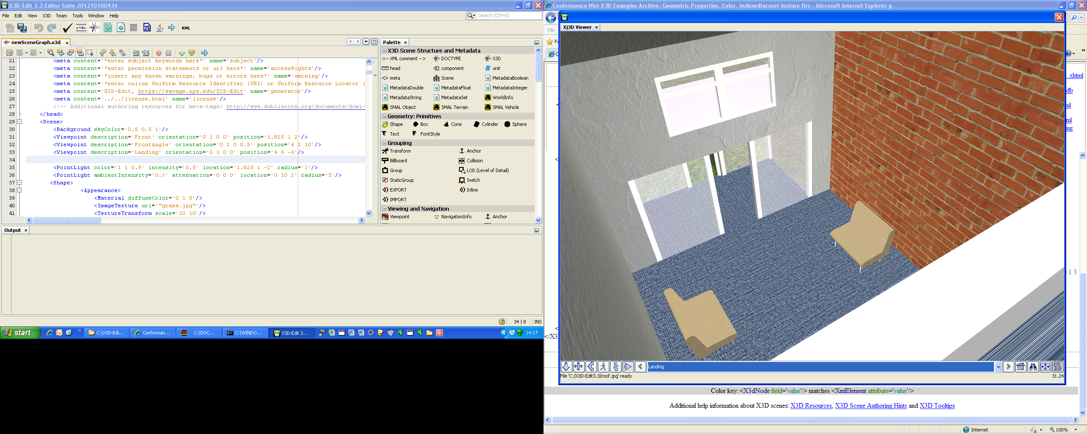

Front:

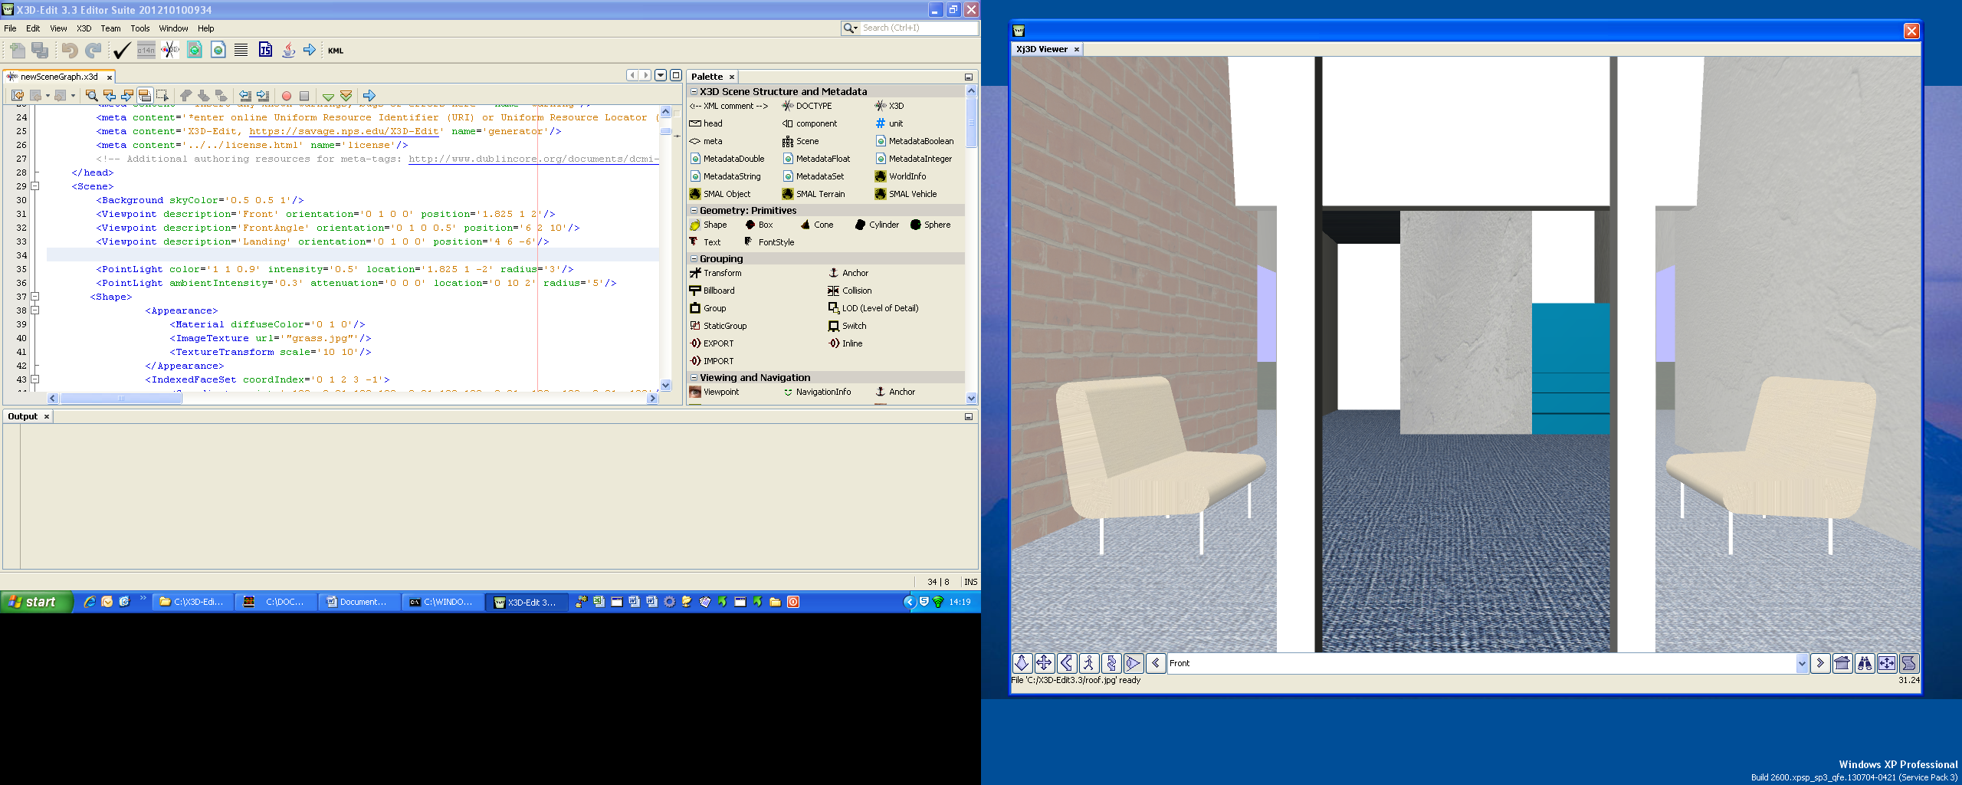

Front Angle:

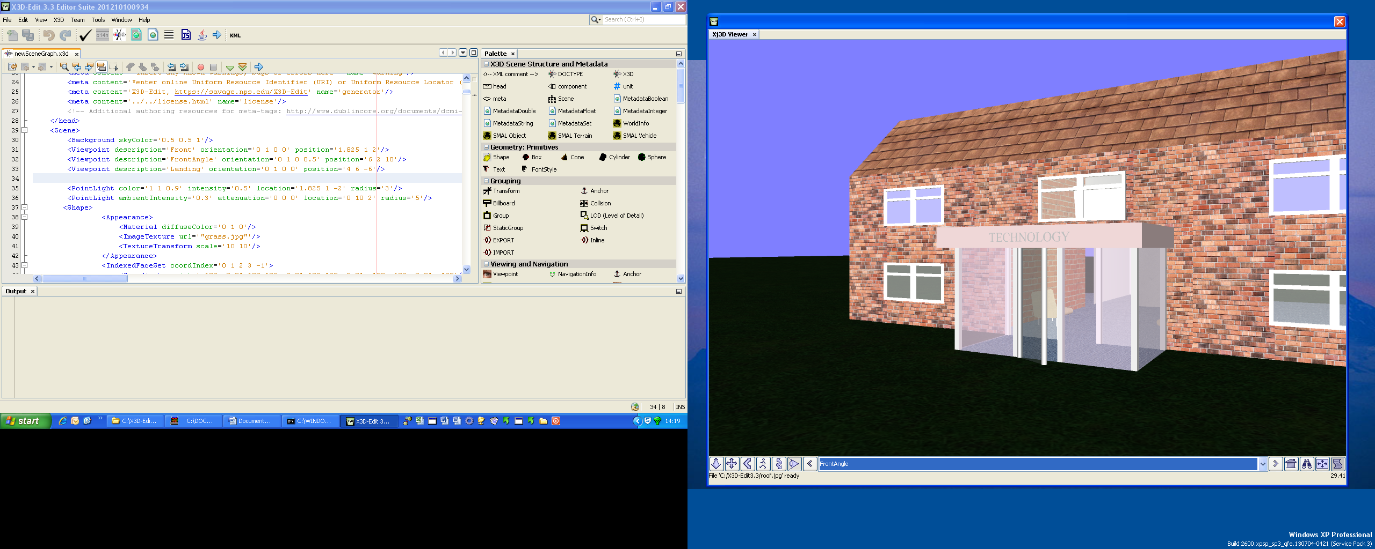

Conclusion:

I would have liked to have spent more time looking at textures, unfortunately I didn’t get time to apply textures to all surfaces and I’m still not completely happy with how to use them with indexed face sets. I would have liked to have done more with animation, in particular touch sensors but time did not permit this. I found the software “X3dEdit” was a huge hindrance to my progress, the software was unreliable and failed to run on a few of the machines I have access. I also found that some of the viewpoints, the landing view in particular didn’t render correctly until some user interaction forced it, eg , changing the viewing angle.